CPP Lecture Assignments:
// 1:write program to test Hello World.
#include<iostream>
using namespace std;
int main(){
cout<<"Hello World"<<endl;
return 0;
}

// 2:Write a program to adddition of two numbers .
#include<iostream>
using namespace std;
int main(){
int no1, no2, no3;
cout<<"No.1: "<<endl;
cin>>no1;
cout<<"No.2: "<<endl;
cin>>no2;
no3 = no1 + no2;
cout<<"Addition of two numbers is : "<<no3<<endl;
return 0;
}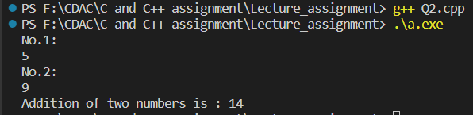
// 3:Write a program to swap two numbers.
#include<iostream>
using namespace std;
int main(){
int no1, no2;
cout<<"No.1: ";
cin>>no1;
cout<<"No.2: "<<endl;
cin>>no2;

no1 = no1 + no2;
no2 = no1 - no2;
no1 = no1 - no2;
cout<<"Swapped numbers are: "<<endl;
cout<<"No.1: "<<no1<<endl;
cout<<"No.2: "<<no2<<endl;
return 0;
}
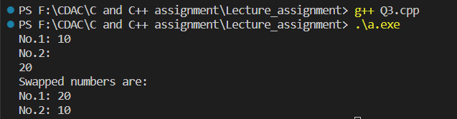

// 4. Write a program to accept an integer and check if it is even or odd.
#include<iostream>
using namespace std;

int main(){
int no;
cout<<"Enter the no.: ";
cin>>no;
if(no % 2 == 0){
cout<<"It is even."<<endl;
}
else{
cout<<"It is odd."<<endl;
}
return 0;
}
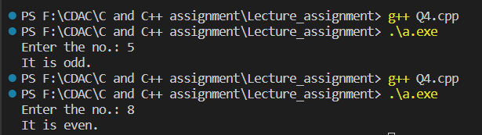

// 5. Write a program to accept a number and check if it is divisible by 5 and 7.
#include<iostream>
using namespace std;

int main(){
int no;
cout<<"Enter the number: ";
cin>>no;
if(no % 5 == 0 && no % 7 == 0){
cout<<"It is divisible by 5 and 7."<<endl;
}
else{
cout<<"Not divisible by 5 and 7."<<endl;
}
return 0;
}
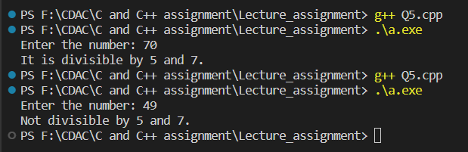

/*6. Write a program, which accepts annual basic salary of an employee and calculates and displays the Income tax as per the following rules.
Basic: < 1, 50,000 Tax = 0
1, 50,000 to 3,00,000 Tax = 20%
> 3,00,000 Tax = 30%
*/
#include<iostream>
using namespace std;

int main(){
int basic_sal;
int tax;
cout<<"Enter the salary: ";
cin>>basic_sal;

if(basic_sal < 150000){
tax = 0;
cout<<"Income tax is : "<<tax<<endl;
}
else if(basic_sal >= 150000 && basic_sal <= 300000){
tax = 20;
basic_sal = basic_sal * 0.2;
cout<<"Income tax is : "<<basic_sal<<endl;
}
else{
tax = 30;
basic_sal = basic_sal * 0.3;
cout<<"Income tax is :"<<basic_sal<<endl;
}
return 0;
}
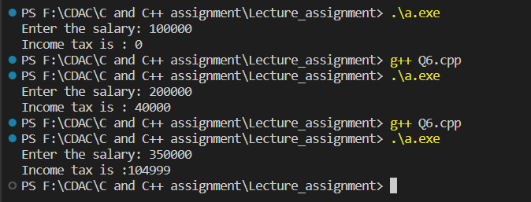

/*7. Accept a lowercase character from the user and check whether the character is a vowel or consonant.
(Hint: a, e, i, o, u are vowels)*/
#include<iostream>
using namespace std;

int main(){
char alpha;
cout<<"Enter the character: ";
cin>>alpha;

if(alpha == 'a' || alpha == 'e' || alpha == 'i' || alpha == 'o' || alpha == 'u'){
cout<<"Character is a vowel."<<endl;
}
else if(alpha >= 97 && alpha <= 122){
cout<<"Character is a consonant."<<endl;
}
else{
cout<<"It is a character."<<endl;
}
return 0;
}
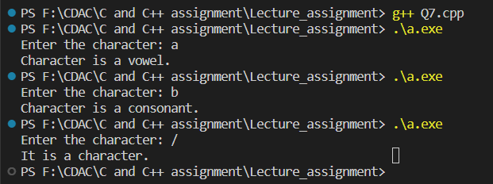

// 8. Write a program to input angles of a triangle and check whether triangle is valid or not.
#include<iostream>
using namespace std;

int main(){
int angle1, angle2, angle3, sum;
cout<<"Angle1: ";
cin>>angle1;
cout<<"\nAngle2: ";
cin>>angle2;
cout<<"\nAngle3: ";
cin>>angle3;

sum = angle1 + angle2 + angle3;
if(sum == 180){
cout<<"Triangle is valid."<<endl;
}
else{
cout<<"Triangle is invalid"<<endl;
}
return 0;
}
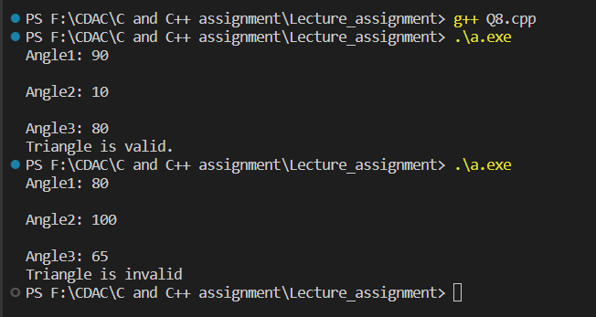

// 9:Write a program to find factorial of a given number. ex:no5 fact=5*4*3*2*1=120
#include<iostream>
using namespace std;

int main(){
int no, fact = 1;
cout<<"Enter the number: ";
cin>>no;
for (int i = 1; i <= no; i++)
{
fact = fact * i;
}
cout<<"\nFactorial of "<<no<<" is: "<<fact;
return 0;
}
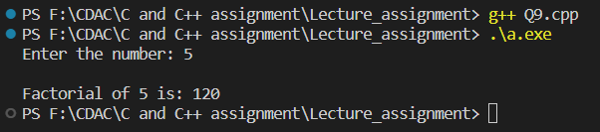

// 10:Write a program to find m to the power n. m=3 and n=4 so 3*3*3*3
#include<iostream>
using namespace std;

int main(){
int m, n, prod=1;
cout<<"Enter m value: ";
cin>>m;
cout<<"\nEnter n value: ";
cin>>n;
while(n != 0){
prod *= m;
--n;
}

cout<<prod;
return 0;
}
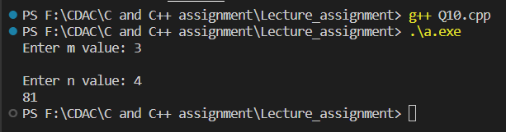

// 11:Check if number is a prime number or not.:
#include<iostream>
using namespace std;

int main(){
int no;
bool flag = true;
cout<<"Enter the no.: ";
cin>>no;

for(int i = 2; i<no; i++){
if(no % i == 0){
flag = false;
break;
}
else{
flag = true;
}
}
if(flag == true){
cout<<"\nNumber is a prime number.";
}
else{
cout<<"Number is not a prime number.";
}
return 0;
}
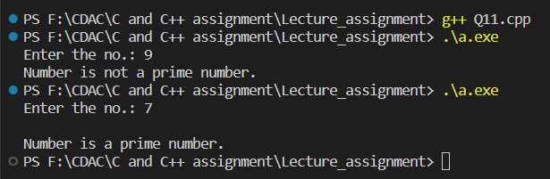

// 12:Sum of series :
// 1+2+3+….+n
#include<iostream>
using namespace std;

int main(){
int n, sum;
cout<<"Enter the number: ";
cin>>n;
sum = n * ((n+1) / 2);
cout<<"\nSum of series is: "<<sum;
return 0;
}

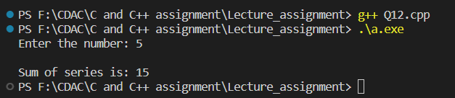

// 13:Check whether the number is palindrome or not?
#include<iostream>
using namespace std;
int main(){
int a, b, c, s=0;
cout<<"Enter the number: ";
cin>>a;
c = a;
while(a > 0){
b = a % 10;
s = (s * 10) + b;
a = a / 10;
}
if(s == c){
cout<<"\nThe number is a palindrome.";
}
else{
cout<<"The number is not a palindrome.";
}
return 0;
}
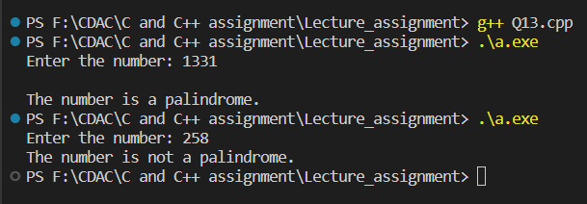

// 14:Write a program to find sum of all even and odd numbers between 1 to n.
#include<iostream>
using namespace std;
int main(){
int n, sumOdd = 0, sumEven = 0;
cout<<"Enter the number:";
cin>>n;
for(int i = 2; i<n; i++){
if(i % 2 == 0){
sumEven += i;
}
else{
sumOdd += i;
}
}
cout<<"\nSum of even numbers is: "<<sumEven;
cout<<"\nSum of odd numbers is: "<<sumOdd;
return 0;
}
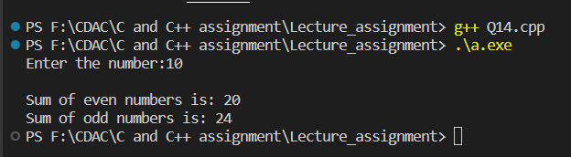
// 15: Write a program to enter a number and print its reverse.
#include<iostream>
using namespace std;
int main(){
int no, q, r;
cout<<"Enter the number: ";
cin>>no;
while(no != 0){
r = no % 10;
cout<<r;
no = no / 10;
}
return 0;
}
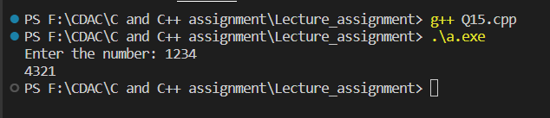

// 16:Write a program to print all Prime numbers between 1 to n.
#include<iostream>
using namespace std;

bool isPrime(int n){
if(n == 1 || n == 0){
return false;
}
for(int i = 2; i<=n/2; i++){
if(n % i == 0){
return false;
}
}
return true;
}
int main(){
int n;
cout<<"Enter the number: ";
cin>>n;
for (int i = 1; i <= n; i++)
{
if(isPrime(i)){
cout<<i<<endl;
}
}
return 0;
}
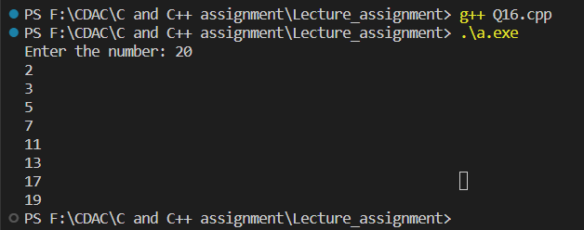

// 17:Write a program to check entered number is Armstrong number or not.
#include<iostream>
#include<cmath>
using namespace std;
int main(){
int num, orgNum, rem, n=0, result = 0, power;
cout<<"Enter the number: ";
cin>>num;
orgNum = num;

while(orgNum != 0){
orgNum /= 10;
++n;
}
orgNum = num;
while(orgNum != 0){
rem = orgNum % 10;
power = round(pow(rem, n));
result += power;
orgNum /= 10;
}
if(result == num){
cout<<num<<" is an Armstrong number.";
}
else{
cout<<num<<" is not an Armstrong number";
}
return 0;
}
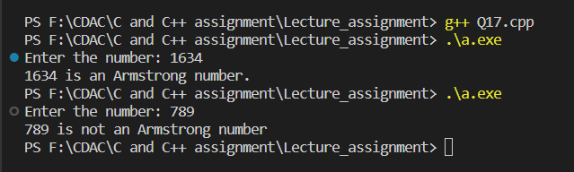
// 18:Write a program to find greatest of three numbers using nested if-else.
#include<iostream>
using namespace std;
int main(){
int no1, no2, no3;
cout<<"Enter no1.: ";
cin>>no1;
cout<<"\nEnter no2.: ";
cin>>no2;
cout<<"\nEnter no3.: ";
cin>>no3;

if(no1 > no2){
if(no1 > no3){
cout<<no1<<" is greatest."<<endl;
}
else{
cout<<no3<<" is greatest."<<endl;
}
}
else{
if(no2 > no3){
cout<<no2<<" is greatest."<<endl;
}
else{
cout<<no3<<" is greatest."<<endl;
}
}
return 0;
}
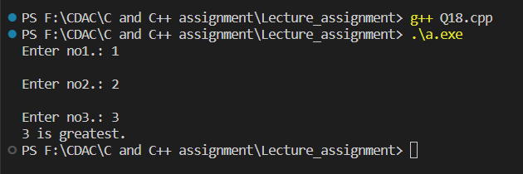

// 19:Create menu driven program for Pizza Shop.And display total amount.
#include<iostream>
using namespace std;

int main(){
int choice,total=0;
do{
cout<<"----------Pizza Menu-----------"<<endl;
cout<<"1. Mexican Pizza --> $25"<<endl;
cout<<"2. Farmhouse Pizza --> $30"<<endl;
cout<<"3. Pasta Pizza --> $20"<<endl;
cout<<"4. Pepperoni Pizza --> $22"<<endl;
cout<<"5. Paneer Pizza --> $35"<<endl;
cout<<"6. Exit"<<endl;

cout<<"Enter your choice: ";
cin>>choice;
switch (choice)
{
case 1:
total += 25;
cout<<"You chose Mexican pizza, your bill is: $"<<total<<endl;
break;
case 2:
total += 30;
cout<<"You chose Farmhouse pizza, your bill is: $"<<total<<endl;
break;
case 3:
total += 20;
cout<<"You chose Pasta pizza, your bill is: $"<<total<<endl;
break;
case 4:
total += 22;
cout<<"You chose Pepperoni pizza, your bill is: $"<<total<<endl;
break;
case 5:
total += 35;
cout<<"You chose Paneer pizza, your bill is: $"<<total<<endl;
break;
case 6:
cout<<"Your total bill is: "<<total<<endl;
break;
default:
cout<<"Invalid choice.";
break;
}
}while(choice != 6);
return 0;
}
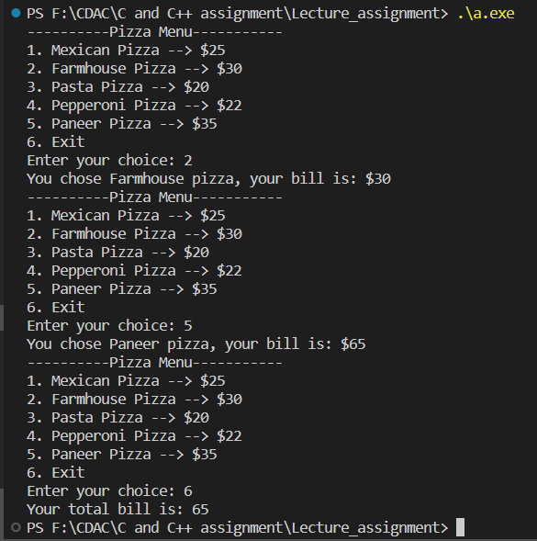

// 20:Accept a single digit from the user and display it in words. For example, if digit entered is 9, display Nine.
#include<iostream>
using namespace std;

int main(){
int digit;
cout<<"Enter the digit: ";
cin>>digit;
switch (digit)
{
case 0:
cout<<"Zero"<<endl;
break;
case 1:
cout<<"One"<<endl;
break;
case 2:
cout<<"Two"<<endl;
break;
case 3:
cout<<"Three"<<endl;
break;
case 4:
cout<<"Four"<<endl;
break;
case 5:
cout<<"Five"<<endl;
break;
case 6:
cout<<"Six"<<endl;
break;
case 7:
cout<<"Seven"<<endl;
break;
case 8:
cout<<"Eight"<<endl;
break;
case 9:
cout<<"Nine"<<endl;
break;
default:
cout<<"Invalid choice"<<endl;
break;
}
return 0;
}
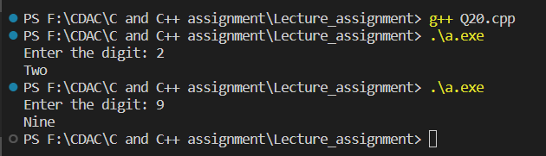

/*21. Write a program, which accepts two integers and an operator as a character (+ - * / ), performs the corresponding operation and displays the result.*/
#include<iostream>
using namespace std;

int main(){
int no1, no2, result;
char opr;

cout<<"Enter no1: ";
cin>>no1;
cout<<"\nEnter no2: ";
cin>>no2;
cout<<"\nEnter the operator: ";
cin>>opr;
switch (opr)
{
case '+':
result = no1 + no2;
cout<<"Result: "<<result;
break;
case '-':
result = no1 - no2;
cout<<"Result: "<<result;
break;
case '*':
result = no1 * no2;
cout<<"Result: "<<result;
break;
case '/':
result = no1 / no2;
cout<<"Result: "<<result;
break;
default:
cout<<"Invalid choice.";
break;
}
return 0;
}
